Project Design Phase-II
Data Flow Diagram & User Stories

Date | 11-10-2026
Team ID | SWUID2026235621
Project Name | iMovies - Cinema Booking Platform
Maximum Marks | 4 Marks

Data Flow Diagrams:
A Data Flow Diagram (DFD) illustrates how data moves within the iMovies - Cinema Booking Platform platform. It captures how users (moviegoers and cinema administrators) interact with the system, how information flows between different components, and where the data is stored.
Example: DFD Level 0 (Industry Standard)

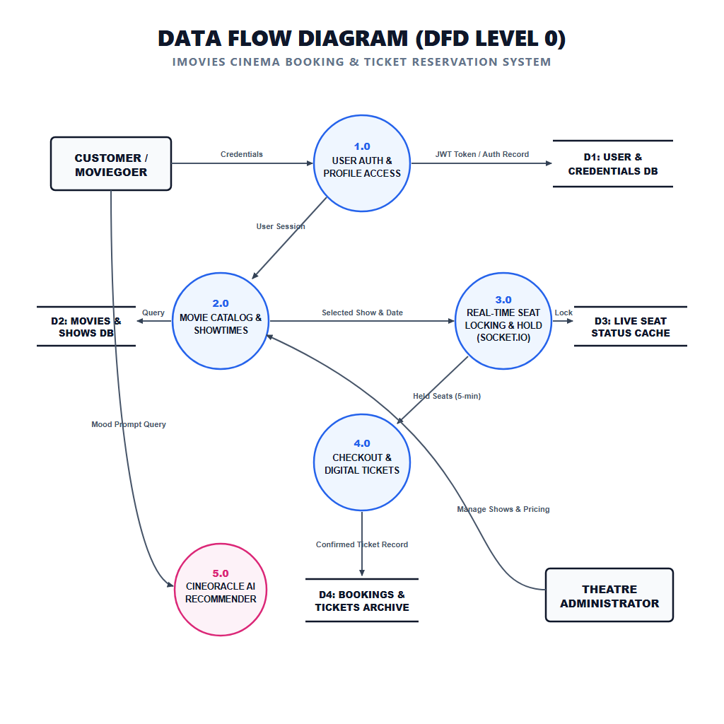

User Stories

User Story Table – iMovies Cinema Booking Platform
User Type | Functional Requirement (Epic) | User Story / Task | Acceptance Criteria | Priority | Release
Moviegoer |  | As a moviegoer, I can browse movies and filter by city, genre, and language. | Filtered movie releases update instantly on the homepage grid. | High | Sprint-1
  Movie Discovery
 |  | As a user, I can watch official YouTube movie trailers in an HD modal. | Video stream plays instantly without leaving the booking flow. | Medium | Sprint-2
  Trailer Preview
Moviegoer | AI Recommendations |  | Intelligent mood-matched movie recommendations are displayed. | High | Sprint-1
  As a user, I can ask the AI Cinema Oracle for personalized recommendations.
User | Real-Time Seat Locking | As a user, I can select seats with live WebSocket status updates. | Seats lock in real-time, preventing concurrent double-booking. | Medium | Sprint-2
Moviegoer | Ticket Reservation | As a user, I can confirm booking and view my digital tickets. | Booking confirmation with seat IDs and QR reference is generated. | High | Sprint-2
Cinema Admin | Admin Showtime Management | As an admin, I can create and schedule cinema showtimes across screens. | New showtime is published and immediately available for booking. | High | Sprint-2
user |  | As an admin, I can configure theater screens and seating layouts. | Seating matrices reflect accurate capacity per auditorium. | Medium | Sprint-2
  Cinema Venue Management
Admin | Booking Auditing | As an admin, I can audit live seat reservations and ticket sales. | Real-time occupancy metrics are displayed in the admin dashboard. | High | Sprint-1

